Compound-Complex Sentence

✅ Definition:
# Source: AI Source: Provided by: [Data Path: Persons Table -> ID Column: 1, Name_En Column: Motasem Essam] -> From: [Chatgpt (GPT-4-turbo)] on [7/29/2025]
A compound-complex sentence is a sentence that has:
- At least two independent clauses
- At least one dependent clause
🧠 It’s a blend of a compound sentence and a complex sentence.

🧩 Structure Summary:
# Source: AI Source: Provided by: [Data Path: Persons Table -> ID Column: 1, Name_En Column: Motasem Essam] -> From: [Chatgpt (GPT-4-turbo)] on [7/29/2025]
Independent Clause + [Coordinating Conjunction] + Independent Clause + [Dependent Clause(s)]
OR
Dependent Clause + Independent Clause + [Coordinating Conjunction] + Independent Clause

🔗 Uses Both:
# Source: AI Source: Provided by: [Data Path: Persons Table -> ID Column: 1, Name_En Column: Motasem Essam] -> From: [Chatgpt (GPT-4-turbo)] on [7/29/2025]
- Coordinating Conjunctions (FANBOYS: for, and, nor, but, or, yet, so)
- Subordinating Conjunctions (because, when, although, if, etc.)

✏️ Examples of Compound-Complex Sentences:
# Source: AI Source: Provided by: [Data Path: Persons Table -> ID Column: 1, Name_En Column: Motasem Essam] -> From: [Chatgpt (GPT-4-turbo)] on [7/29/2025]
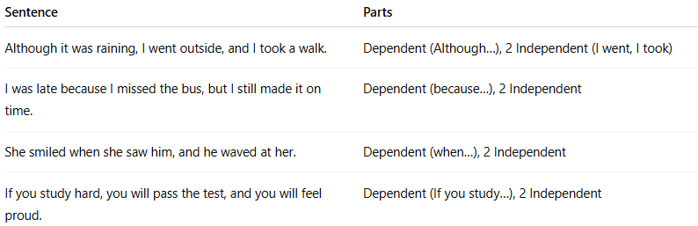
Sentence | Parts
Although it was raining, I went outside, and I took a walk. | Dependent (Although…), 2 Independent (I went, I took)
I was late because I missed the bus, but I still made it on time. | Dependent (because…), 2 Independent
She smiled when she saw him, and he waved at her. | Dependent (when…), 2 Independent
If you study hard, you will pass the test, and you will feel proud. | Dependent (If you study…), 2 Independent

🧠 How to Identify a Compound-Complex Sentence:
# Source: AI Source: Provided by: [Data Path: Persons Table -> ID Column: 1, Name_En Column: Motasem Essam] -> From: [Chatgpt (GPT-4-turbo)] on [7/29/2025]
- Look for two or more independent clauses
- Look for at least one dependent clause
- Look for both:
  - Coordinating conjunctions (and, but, so…)
  - Subordinating conjunctions (because, although…)

🚫 Common Confusion:
# Source: AI Source: Provided by: [Data Path: Persons Table -> ID Column: 1, Name_En Column: Motasem Essam] -> From: [Chatgpt (GPT-4-turbo)] on [7/29/2025]
- Not just long = Some long sentences are just complex or compound.
- Not just a list = A sentence with many nouns/verbs isn’t compound-complex unless it has multiple clauses of both types.

🔍 Quick Check – Compound-Complex or Not?
# Source: AI Source: Provided by: [Data Path: Persons Table -> ID Column: 1, Name_En Column: Motasem Essam] -> From: [Chatgpt (GPT-4-turbo)] on [7/29/2025]
- I stayed home because I was sick. ❌ (Complex)
- She was tired, but she finished the project. ❌ (Compound)
- While I was working, the phone rang, and the dog barked. ✅ (Compound-Complex)
- They studied hard, and they passed the test. ❌ (Compound)

